**Edit Text Design**

**EXAMPLE : 1**

edit_text_background.xml

*<?***xml version="1.0" encoding="UTF-8"***?>*<**selector xmlns:android="http://schemas.android.com/apk/res/android"**>  
 <**item  
 android:state_focused="true"**>  
 <**layer-list**>  
 <**item**>  
 <**shape**>  
 <**solid  
 android:color="#DFDCDB"** />  
  
 <**stroke  
 android:width="@dimen/_1sdp"  
 android:color="#FF0057"**/>  
  
 <**corners  
 android:bottomLeftRadius="@dimen/_2sdp"  
 android:bottomRightRadius="@dimen/_2sdp"  
 android:topLeftRadius="@dimen/_2sdp"  
 android:topRightRadius="@dimen/_2sdp"** />  
  
 <**padding  
 android:bottom="@dimen/_5sdp"  
 android:left="@dimen/_5sdp"  
 android:right="@dimen/_5sdp"  
 android:top="@dimen/_5sdp"** />  
 </**shape**>  
 </**item**>  
 </**layer-list**>  
 </**item**>  
  
 <**item**>  
 <**layer-list**>  
 <**item**>  
 <**shape**>  
 <**solid  
 android:color="#FFFFFF"** />  
  
 <**stroke  
 android:width="@dimen/_1sdp"  
 android:color="#000000"**/>  
  
 <**corners  
 android:bottomLeftRadius="@dimen/_2sdp"  
 android:bottomRightRadius="@dimen/_2sdp"  
 android:topLeftRadius="@dimen/_2sdp"  
 android:topRightRadius="@dimen/_2sdp"** />  
  
 <**padding  
 android:bottom="@dimen/_5sdp"  
 android:left="@dimen/_5sdp"  
 android:right="@dimen/_5sdp"  
 android:top="@dimen/_5sdp"** />  
 </**shape**>  
 </**item**>  
 </**layer-list**>  
 </**item**>  
</**selector**>

activity_main.xml

*<?***xml version="1.0" encoding="utf-8"***?>*<**LinearLayout xmlns:android="http://schemas.android.com/apk/res/android"  
 android:layout_width="match_parent"  
 android:layout_height="wrap_content"  
 android:orientation="vertical"  
 android:padding="@dimen/_5sdp"**>  
  
 <**LinearLayout  
 android:layout_width="match_parent"  
 android:layout_height="match_parent"  
 android:orientation="vertical"**>  
  
 <**TextView  
 android:layout_width="match_parent"  
 android:layout_height="wrap_content"  
 android:text="Username"  
 android:textColor="#0b0b0a"** />  
  
 <**EditText  
 android:layout_width="match_parent"  
 android:layout_height="@dimen/_40sdp"  
 android:layout_marginTop="@dimen/_2sdp"  
 android:background="@drawable/edit_text_background"** />  
 </**LinearLayout**>  
  
 <**LinearLayout  
 android:layout_width="match_parent"  
 android:layout_height="match_parent"  
 android:layout_marginTop="@dimen/_10sdp"  
 android:orientation="vertical"**>  
  
 <**TextView  
 android:layout_width="match_parent"  
 android:layout_height="wrap_content"  
 android:text="Username"  
 android:textColor="#0b0b0a"** />  
  
 <**EditText  
 android:layout_width="match_parent"  
 android:layout_height="@dimen/_40sdp"  
 android:layout_marginTop="@dimen/_2sdp"  
 android:background="@drawable/edit_text_background"** />  
 </**LinearLayout**>  
</**LinearLayout**>

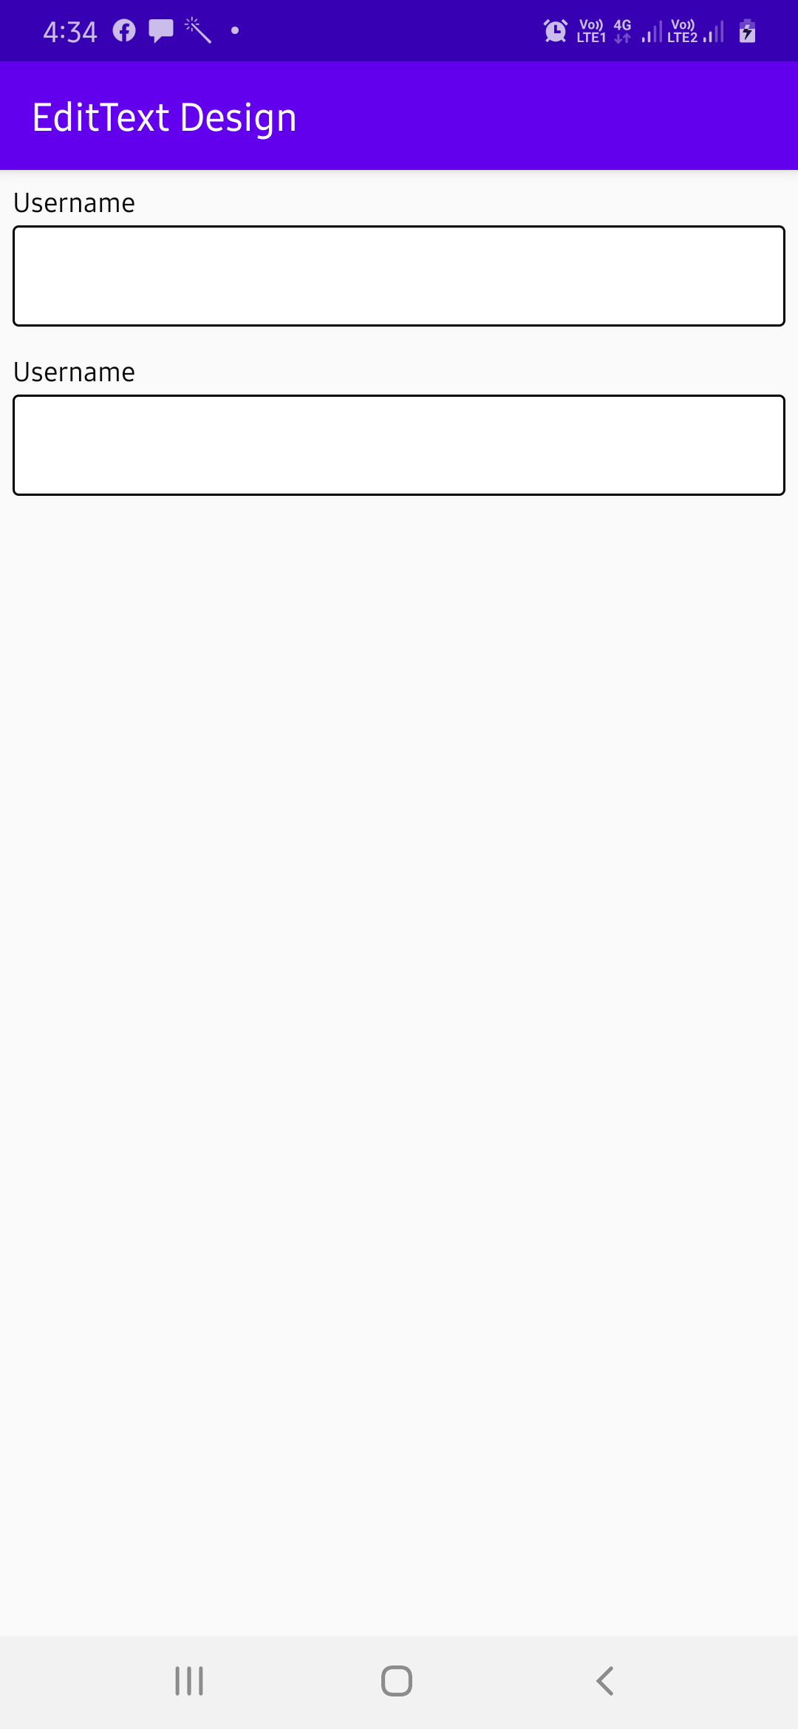  
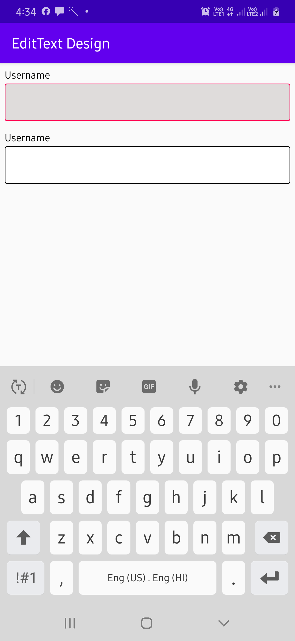

**EXAMPLE : 2**

edit_text_background.xml

*<?***xml version="1.0" encoding="utf-8"***?>*<**shape  
 xmlns:android="http://schemas.android.com/apk/res/android"  
 android:shape="rectangle"** >  
  
 <**stroke  
 android:width="@dimen/_1sdp"  
 android:color="#000000"**/>  
  
 <**solid  
 android:color="#FFFFFF"** />  
  
 <**corners  
 android:bottomLeftRadius="@dimen/_26sdp"  
 android:bottomRightRadius="@dimen/_26sdp"  
 android:topLeftRadius="@dimen/_26sdp"  
 android:topRightRadius="@dimen/_26sdp"** />  
  
 <**padding  
 android:bottom="@dimen/_5sdp"  
 android:left="@dimen/_5sdp"  
 android:right="@dimen/_5sdp"  
 android:top="@dimen/_5sdp"** />  
</**shape**>

activity_main.xml

*<?***xml version="1.0" encoding="utf-8"***?>*<**LinearLayout xmlns:android="http://schemas.android.com/apk/res/android"  
 android:layout_width="match_parent"  
 android:layout_height="wrap_content"  
 android:orientation="vertical"  
 android:padding="@dimen/_5sdp"**>  
  
 <**EditText  
 android:layout_width="match_parent"  
 android:layout_height="wrap_content"  
 android:layout_margin="10dp"  
 android:background="@drawable/edit_text_background"  
 android:drawableStart="@drawable/ic_account_circle_black_24dp"  
 android:drawableLeft="@drawable/ic_account_circle_black_24dp"  
 android:drawablePadding="10dp"  
 android:hint="User Name"  
 android:padding="15dp"  
 android:textColor="#000000"** />  
  
 <**EditText  
 android:layout_width="match_parent"  
 android:layout_height="wrap_content"  
 android:layout_margin="10dp"  
 android:background="@drawable/edit_text_background"  
 android:drawableStart="@drawable/ic_account_circle_black_24dp"  
 android:drawableLeft="@drawable/ic_account_circle_black_24dp"  
 android:drawablePadding="10dp"  
 android:hint="Password"  
 android:padding="15dp"  
 android:textColor="#000000"** />  
</**LinearLayout**>

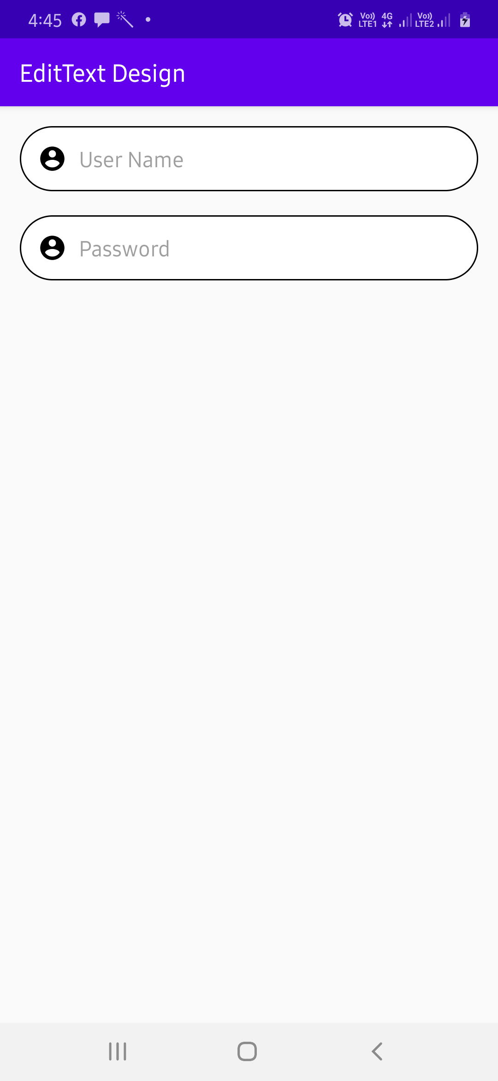

**EXAMPLE : 3**

activity_main.xml

*<?*xml version="1.0" encoding="utf-8"*?>*<LinearLayout  
 xmlns:android="http://schemas.android.com/apk/res/android"  
 xmlns:app="http://schemas.android.com/apk/res-auto"  
 xmlns:tools="http://schemas.android.com/tools"  
 android:layout_width="match_parent"  
 android:layout_height="wrap_content"  
 android:layout_gravity="center"  
 android:orientation="vertical"  
 tools:context=".MainActivity">  
  
 <ScrollView  
 android:layout_width="match_parent"  
 android:layout_height="wrap_content">  
  
 <LinearLayout  
 android:layout_width="match_parent"  
 android:layout_height="wrap_content"  
 android:layout_margin="10dp"  
 android:orientation="vertical">  
  
 <EditText  
 android:layout_width="match_parent"  
 android:layout_height="wrap_content"  
 android:layout_margin="10dp"  
 android:padding="15dp"  
 android:background="@drawable/edit_text_background"  
 android:drawableLeft="@drawable/ic_person_black_24dp"  
 android:drawableStart="@drawable/ic_person_black_24dp"  
 android:drawablePadding="20dp"  
 android:paddingLeft="8dp"  
 android:paddingRight="12dp"  
 android:paddingStart="8dp"  
 android:paddingEnd="12dp"  
 android:paddingTop="12dp"  
 android:paddingBottom="12dp"  
 android:hint="User Name"  
 android:textColor="#000000"/>  
  
 <EditText  
 android:layout_width="match_parent"  
 android:layout_height="wrap_content"  
 android:layout_margin="10dp"  
 android:padding="15dp"  
 android:background="@drawable/edit_text_background"  
 android:drawableLeft="@drawable/ic_lock_black_24dp"  
 android:drawableStart="@drawable/ic_lock_black_24dp"  
 android:drawablePadding="20dp"  
 android:paddingLeft="8dp"  
 android:paddingRight="12dp"  
 android:paddingStart="8dp"  
 android:paddingEnd="12dp"  
 android:paddingTop="12dp"  
 android:paddingBottom="12dp"  
 android:hint="Password"  
 android:textColor="#000000"/>  
 </LinearLayout>  
 </ScrollView>  
</LinearLayout>

Create a file called ic_person_black_24dp.xml inside Drawable folder.

<vector xmlns:android="http://schemas.android.com/apk/res/android"  
 android:width="24dp"  
 android:height="24dp"  
 android:viewportWidth="24.0"  
 android:viewportHeight="24.0">  
 <path  
 android:fillColor="#000000"  
 android:pathData="M12,12c2.21,0 4,-1.79 4,-4s-1.79,-4 -4,-4 -4,1.79 -4,4 1.79,4 4,4zM12,14c-2.67,0 -8,1.34 -8,4v2h16v-2c0,-2.66 -5.33,-4 -8,-4z"/>  
</vector>

Create a file called ic_lock_black_24dp.xml inside Drawable folder.

<vector xmlns:android="http://schemas.android.com/apk/res/android"  
 android:width="24dp"  
 android:height="24dp"  
 android:viewportWidth="24.0"  
 android:viewportHeight="24.0">  
 <path  
 android:fillColor="#000000"  
 android:pathData="M18,8h-1L17,6c0,-2.76 -2.24,-5 -5,-5S7,3.24 7,6v2L6,8c-1.1,0 -2,0.9 -2,2v10c0,1.1 0.9,2 2,2h12c1.1,0 2,-0.9 2,-2L20,10c0,-1.1 -0.9,-2 -2,-2zM12,17c-1.1,0 -2,-0.9 -2,-2s0.9,-2 2,-2 2,0.9 2,2 -0.9,2 -2,2zM15.1,8L8.9,8L8.9,6c0,-1.71 1.39,-3.1 3.1,-3.1 1.71,0 3.1,1.39 3.1,3.1v2z"/>  
</vector>

Create a file called edit_text_background.xml inside Drawable folder.

*<?*xml version="1.0" encoding="utf-8"*?>*<layer-list xmlns:android="http://schemas.android.com/apk/res/android">  
  
 <item>  
 <shape>  
 <corners android:radius="6dp" />  
 <solid android:color="@android:color/white" />  
 </shape>  
 </item>  
 <item>  
 <shape>  
 <solid android:color="#AAAAAA" />  
 <corners android:radius="6dp" />  
 </shape>  
 </item>  
 <item  
 android:left="34dp">  
 *<!-- left is icon size + 2x side padding around icon-->  
 <!-- 18 + 8 + 8 -->* <shape>  
 <solid android:color="@android:color/white" />  
 <corners android:radius="6dp"  
 android:topRightRadius="6dp"  
 android:topLeftRadius="0dp"  
 android:bottomRightRadius="6dp"  
 android:bottomLeftRadius="0dp"/>  
 </shape>  
 </item>  
 <item>  
 <shape>  
 <corners android:radius="6dp" />  
 <solid android:color="@android:color/transparent" />  
 <stroke  
 android:width="1dp"  
 android:color="#BBBBBB" />  
 </shape>  
 </item>  
</layer-list>

Run application

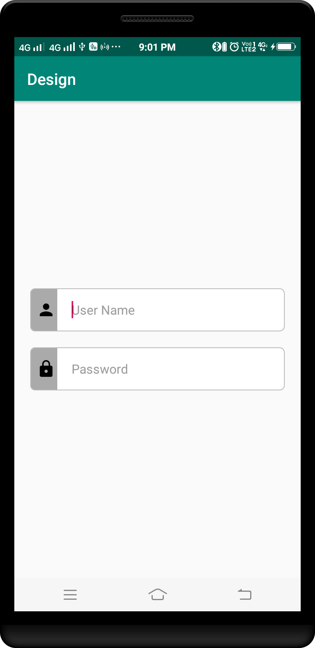

**EXAMPLE :4**

activity_main.xml

*<?*xml version="1.0" encoding="utf-8"*?>*<LinearLayout  
 xmlns:android="http://schemas.android.com/apk/res/android"  
 xmlns:app="http://schemas.android.com/apk/res-auto"  
 xmlns:tools="http://schemas.android.com/tools"  
 android:layout_width="match_parent"  
 android:layout_height="wrap_content"  
 android:layout_gravity="center"  
 android:orientation="vertical"  
 android:background="#FFFFFF"  
 tools:context=".MainActivity">  
  
 <ScrollView  
 android:layout_width="match_parent"  
 android:layout_height="wrap_content">  
  
 <LinearLayout  
 android:layout_width="match_parent"  
 android:layout_height="wrap_content"  
 android:layout_margin="10dp"  
 android:orientation="vertical">  
  
 <RelativeLayout  
 android:layout_width="match_parent"  
 android:layout_height="wrap_content"  
 android:orientation="vertical">  
  
 <EditText  
 android:layout_width="match_parent"  
 android:layout_height="wrap_content"  
 android:layout_gravity="center"  
 android:layout_marginBottom="10dp"  
 android:layout_marginTop="10dp"  
 android:background="@drawable/edit_text_background"  
 android:padding="20dp"  
 android:textColor="#FFFFFF"/>  
  
 <TextView  
 android:layout_width="wrap_content"  
 android:layout_height="wrap_content"  
 android:paddingLeft="5dp"  
 android:paddingRight="5dp"  
 android:layout_marginLeft="10dp"  
 android:layout_marginStart="10dp"  
 android:background="#FFFFFF"  
 android:gravity="center"  
 android:text="Username"  
 android:textColor="#741c7a"/>  
 </RelativeLayout>  
  
 <RelativeLayout  
 android:layout_width="match_parent"  
 android:layout_height="wrap_content"  
 android:orientation="vertical">  
  
 <EditText  
 android:layout_width="match_parent"  
 android:layout_height="wrap_content"  
 android:layout_gravity="center"  
 android:layout_marginBottom="10dp"  
 android:layout_marginTop="10dp"  
 android:background="@drawable/edit_text_background"  
 android:padding="20dp"  
 android:textColor="#FFFFFF"/>  
  
 <TextView  
 android:layout_width="wrap_content"  
 android:layout_height="wrap_content"  
 android:paddingLeft="5dp"  
 android:paddingRight="5dp"  
 android:layout_marginLeft="10dp"  
 android:layout_marginStart="10dp"  
 android:background="#FFFFFF"  
 android:gravity="center"  
 android:text="Password"  
 android:textColor="#741c7a"/>  
 </RelativeLayout>  
 </LinearLayout>  
 </ScrollView>  
</LinearLayout>

Create a file called edit_text_background.xml inside Drawable folder.

*<?*xml version="1.0" encoding="utf-8"*?>*<shape  
 xmlns:android="http://schemas.android.com/apk/res/android"  
 android:shape="rectangle">  
  
 <stroke  
 android:color="#741c7a"  
 android:width="1dp"/>  
  
 <padding android:left="1dp"  
 android:top="1dp"  
 android:right="1dp"  
 android:bottom="1dp"/>  
  
 <corners  
 android:bottomRightRadius="7dp"  
 android:bottomLeftRadius="7dp"  
 android:topLeftRadius="7dp"  
 android:topRightRadius="7dp"/>  
</shape>

Run application

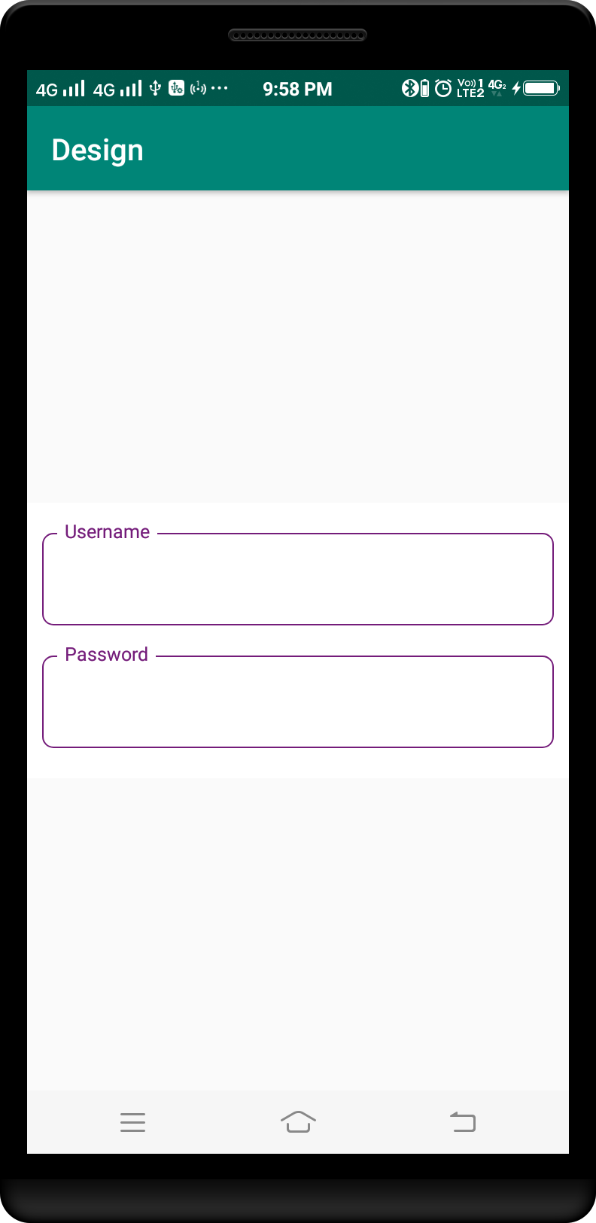

**EXAMPLE :5**

ic_add_medicine.xml

<**vector xmlns:android="http://schemas.android.com/apk/res/android"  
 android:width="24dp"  
 android:height="24dp"  
 android:viewportHeight="24.0"  
 android:viewportWidth="24.0"**>  
 <**path  
 android:fillColor="#211651"  
 android:pathData="M19,3L5,3c-1.1,0 -1.99,0.9 -1.99,2L3,19c0,1.1 0.9,2 2,2h14c1.1,0 2,-0.9 2,-2L21,5c0,-1.1 -0.9,-2 -2,-2zM18,14h-4v4h-4v-4L6,14v-4h4L10,6h4v4h4v4z"** />  
</**vector**>

ic_add_description.xml

<**vector xmlns:android="http://schemas.android.com/apk/res/android"  
 android:width="24dp"  
 android:height="24dp"  
 android:viewportHeight="24.0"  
 android:viewportWidth="24.0"**>  
 <**path  
 android:fillColor="#211651"  
 android:pathData="M17,10L7,10v2h10v-2zM19,3h-1L18,1h-2v2L8,3L8,1L6,1v2L5,3c-1.11,0 -1.99,0.9 -1.99,2L3,19c0,1.1 0.89,2 2,2h14c1.1,0 2,-0.9 2,-2L21,5c0,-1.1 -0.9,-2 -2,-2zM19,19L5,19L5,8h14v11zM14,14L7,14v2h7v-2z"** />  
</**vector**>

edit_text_background.xml

*<?***xml version="1.0" encoding="utf-8"***?>*<**shape xmlns:android="http://schemas.android.com/apk/res/android"  
 android:shape="rectangle"**>  
  
 <**solid android:color="#FFFFFF"** />  
  
 <**stroke  
 android:width="1dp"  
 android:color="#9E9E9E"** />  
  
 <**corners android:radius="6dp"** />  
  
</**shape**>

activity_main.xml

*<?***xml version="1.0" encoding="utf-8"***?>*<**LinearLayout xmlns:android="http://schemas.android.com/apk/res/android"  
 xmlns:app="http://schemas.android.com/apk/res-auto"  
 android:layout_width="match_parent"  
 android:layout_height="match_parent"  
 android:orientation="vertical"**>  
  
 <**LinearLayout  
 android:layout_width="match_parent"  
 android:layout_height="match_parent"  
 android:orientation="vertical"  
 android:padding="@dimen/_16sdp"**>  
  
 <**TextView  
 android:layout_width="match_parent"  
 android:layout_height="wrap_content"  
 android:text="Medicine Name"  
 android:textStyle="normal"**/>  
  
 <**LinearLayout  
 android:layout_width="match_parent"  
 android:layout_height="wrap_content"  
 android:layout_marginTop="@dimen/_2sdp"  
 android:background="@drawable/edit_text_background"  
 android:orientation="horizontal"**>  
  
 <**ImageView  
 android:layout_width="0dp"  
 android:layout_height="wrap_content"  
 android:layout_weight="1"  
 android:padding="@dimen/_12sdp"  
 app:srcCompat="@drawable/ic_add_medicine"** />  
  
 <**View  
 android:layout_width="@dimen/_1sdp"  
 android:layout_height="match_parent"  
 android:background="#9E9E9E"** />  
  
 <**EditText  
 android:id="@+id/editTextMedicineName"  
 android:layout_width="0dp"  
 android:layout_height="wrap_content"  
 android:layout_weight="5.5"  
 android:background="@android:color/transparent"  
 android:inputType="textCapWords"  
 android:padding="@dimen/_12sdp"  
 android:singleLine="true"  
 android:textColorHint="#DBD8D9"** />  
  
 </**LinearLayout**>  
  
 <**TextView  
 android:layout_width="match_parent"  
 android:layout_height="wrap_content"  
 android:layout_marginTop="@dimen/_8sdp"  
 android:alpha="0.8"  
 android:text="@string/medicine_description"  
 android:textStyle="normal"** />  
  
 <**LinearLayout  
 android:layout_width="match_parent"  
 android:layout_height="wrap_content"  
 android:layout_marginTop="@dimen/_2sdp"  
 android:background="@drawable/edit_text_background"  
 android:orientation="horizontal"**>  
  
 <**ImageView  
 android:layout_width="0dp"  
 android:layout_height="wrap_content"  
 android:layout_weight="1"  
 android:padding="@dimen/_12sdp"  
 app:srcCompat="@drawable/ic_add_description"** />  
  
 <**View  
 android:layout_width="@dimen/_1sdp"  
 android:layout_height="match_parent"  
 android:background="#9E9E9E"** />  
  
 <**EditText  
 android:id="@+id/editTextMedicineDescription"  
 android:layout_width="0dp"  
 android:layout_height="wrap_content"  
 android:layout_weight="5.5"  
 android:background="@android:color/transparent"  
 android:inputType="textCapSentences"  
 android:padding="@dimen/_12sdp"  
 android:textColorHint="#DBD8D9"** />  
 </**LinearLayout**>  
 </**LinearLayout**>  
</**LinearLayout**>

